

**SRI VENKATESWARA COLLEGE OF ENGINEERING**

**AND TECHNOLOGY**



**COURSE NAME :**

CRITICAL THINKING, DESIGN THINKING, LEADERSHIP AND TEAM WORK

**COLLEGE NAME :**

SRI VENKATESWARA COLLEGE OF ENGINEERING AND TECHNOLOGY

**BATCH NUMBER :** 05 **TASK NUMBER :** #01 **TASK NAME :**

PRODUCT FAILURE ANALYSIS AND MACHINE FAILURE

ANALYSIS

# TASK #01

2018 Kolkata Bridge Collapse - Product Failure Analysis and Machine Failure Analysis



Overview of the Incident:

* **Date:** September 4, 2018
* **Location:** Majerhat, Alipore, Kolkata, West Bengal, India
* **Casualties:** 3 fatalities, at least 25 injuries
* **Impact:** The bridge collapsed during peak traffic hours, crushing vehicles and causing significant traffic disruption.



## 1. Product Failure Analysis

Product failure analysis examines the failure of the bridge's components and materials, focusing on design, manufacturing, and maintenance aspects.

Key Product Failures Identified:

1.1. Structural Component Failure:

* **Concrete Decking and Girders:** 
  + - **Observation:** The concrete slabs and girders showed severe cracks and spalling (chipping or crumbling).
    - **Analysis:** 
      * **Poor Material Quality:** Inadequate concrete mix ratio leading to reduced strength and durability.
      * **Aging and Wear:** The bridge was over 50 years old, and the concrete had significantly weakened over time.
      * **Corrosion of Reinforcement Bars:** Due to prolonged exposure to pollution and moisture, steel reinforcement bars within the concrete corroded, causing internal pressure that led to cracking and spalling.

1.2. Design and Load-Bearing Failure:

* **Structural Design Limitations:** 
  + - **Observation:** The bridge was not designed to handle the volume and weight of modern-day traffic, including heavy trucks and buses.
    - **Analysis:** 
      * **Overloading:** Increased traffic load exceeded the original design capacity, leading to stress beyond the structural limits.
      * **Design Flaws:** The design did not account for dynamic loads and vibrations from nearby metro construction work.
      * **Lack of Redundancy:** Absence of fail-safe mechanisms or additional support structures, which could have prevented a complete collapse.

1.3. Joint and Connection Failures:

* **Expansion Joints and Bearings:** 
  + - **Observation:** Expansion joints and bearings were found to be heavily corroded and misaligned.
    - **Analysis:** 
      * **Corrosion and Deterioration:** Lack of maintenance led to corrosion, reducing the functionality of joints meant to absorb thermal expansion and contraction.
      * **Restricted Movement:** Corroded joints restricted the bridge's natural movement, causing additional stress on other structural components.
      * **Shear Failure:** The misalignment contributed to shear stress, which likely initiated the structural failure.



## 2. Machine Failure Analysis

Machine failure analysis examines the role of machinery and equipment used in construction, maintenance, and nearby activities, particularly the ongoing metro construction.

2.1. Construction Machinery Impact:

* **Piling Machines and Heavy Equipment (Nearby Metro Construction):** 
  + - **Observation:** Vibrations from piling activities for the Joka-BBD Bag Metro line were reported near the bridge.
    - **Analysis:** 
      * **Vibration-Induced Fatigue:** Continuous vibrations could have caused fatigue in the bridge's foundation and structural elements.
      * **Soil Subsidence:** Vibrations may have led to soil subsidence, undermining the stability of bridge piers.
      * **Foundation Disturbance:** The integrity of the foundation was compromised due to the impact of heavy machinery.

2.2. Maintenance Machinery and Practices:

* **Road Resurfacing Equipment:**

o **Observation:** Bitumen layers were repeatedly added to the bridge surface for road repairs. o **Analysis:**

* + - * **Increased Dead Load:** Each layer of bitumen added extra weight without consideration of the bridge's load-bearing capacity.
      * **Improper Compaction Techniques:** Compaction machines used during resurfacing may have induced vibrations and stress on weakened structural elements.



1. Root Cause Analysis and Contributing Factors:
   1. Lack of Preventive Maintenance:

* + - No comprehensive structural health monitoring system was in place to detect early signs of fatigue or corrosion.
    - Routine inspections were inadequate, and warning signs such as visible cracks and rust were neglected.

* 1. Environmental Factors:

* + - High pollution levels accelerated corrosion in steel components.
    - Water seepage and poor drainage led to moisture accumulation, exacerbating corrosion and concrete deterioration.
  1. Design and Load Miscalculations:

* + - Original design did not account for modern traffic loads and vibrations from nearby construction activities.
    - Absence of load redistribution mechanisms resulted in localized stress accumulation, leading to a cascading collapse.



1. Aftermath and Recommendations:
   1. Immediate Actions Taken:

* + - The remaining portions of the bridge were demolished to prevent further collapse.
    - Rescue operations involved heavy cranes, cutting equipment, and coordinated efforts from NDRF, police, and fire departments.

* 1. Long-Term Recommendations:

1. **Structural Health Monitoring Systems:**

* + - * Implement advanced sensors for real-time monitoring of stress, vibrations, and corrosion.
      * Conduct regular non-destructive testing (NDT) for early defect detection.

2. **Enhanced Design and Load Management:**

* + - * Redesign infrastructure to accommodate increased traffic loads and dynamic vibrations. o Introduce load redistribution systems and fail-safe mechanisms for structural redundancy.

3. **Quality Control and Material Standards:**

* + - * Enforce strict quality control during material selection and construction.
      * Use corrosion-resistant materials and modern construction techniques to extend the lifespan of bridges.

4. **Regulatory and Safety Protocols:**

* + - * Establish stringent safety protocols for construction activities near existing infrastructure.
      * Enforce routine inspections and preventive maintenance practices, with accountability measures for negligence.

1. Data Sheets:

Kolkata_Bridge_Collapse_Analysis.xlsx



1. Conclusion:

The 2018 Kolkata Majerhat Bridge collapse was a tragic reminder of the consequences of neglecting infrastructure maintenance and safety standards. The incident highlights the critical need for:

* + - **Proactive Maintenance:** Routine inspections and early detection systems for structural health monitoring.
    - **Modernization and Retrofitting:** Upgrading aging infrastructure to meet modern traffic and environmental challenges.
    - **Regulatory Oversight and Accountability:** Clear accountability mechanisms to ensure adherence to safety standards.

By learning from this incident and implementing robust safety and maintenance protocols, future tragedies can be prevented.

Would you like additional details on advanced structural health monitoring systems or insights into policy improvements for infrastructure safety?

# Task #02

Here’s a sample table based on the Different literatures :

**Application Complex Problem**

**S.No Justification Domain Identified**

Traditional methods may be slow or

Healthcare (Medical Early detection of

1. inaccurate; AI can improve efficiency and

Diagnosis) diseases using AI

accuracy.

Cities face congestion and pollution; smart

Transportation Real-time optimization

1. systems can enhance mobility and reduce

(Traffic Control) of urban traffic flow

emissions.

One-size-fits-all education does not address

Education (E- Personalized adaptive individual learning needs; AI can customize

1. learning) learning platforms content.

Here’s an explanation of the three different literatures related to the complex problems identified:



## 1. AI in Healthcare – Early Disease Detection

Literature Overview:

Artificial intelligence (AI) has revolutionized the healthcare industry by enabling early detection of diseases such as cancer, kidney failure, and neurological disorders. Various research papers and studies highlight the ability of AI algorithms to analyze large medical datasets, improving accuracy in diagnosis and reducing human errors.

Key Literature Example:

* **Study:** *AI Outperforms Radiologists in Breast Cancer Detection* (*Nature Medicine, 2020*) o **Findings:** AI models trained on thousands of mammograms detected breast cancer with **95% accuracy**, surpassing expert radiologists who had **87% accuracy**.

o **Significance:** AI reduces false positives and false negatives, leading to faster diagnosis and better patient outcomes.

Applications in Real Life:

* DeepMind’s AI model predicts **kidney disease 48 hours in advance** (The Lancet, 2021).
* AI-based screening tools in Apollo Hospitals and Mayo Clinic improve early cancer detection.



## 2. AI in Transportation – Real-time Traffic Optimization

Literature Overview:

Smart cities increasingly use AI-driven traffic control systems to reduce congestion, lower emissions, and improve road safety. AI-powered algorithms analyze real-time traffic data, optimizing signal timings and rerouting vehicles to improve flow efficiency.

Key Literature Example:

* **Study:** *Smart Traffic Management in Singapore* (*IEEE Xplore, 2021*) o **Findings:** AI-driven traffic signal systems reduced urban congestion by **30%**, leading to lower travel times and fuel consumption.

o **Significance:** Real-time data analysis improves road efficiency, reduces emissions, and saves costs.

Applications in Real Life:

* IBM’s AI traffic system in **New York reduced travel time by 10-20%**.
* India’s **Bhopal Smart City AI traffic system cut congestion by 25%** (Government Report, 2022).



## 3. AI in Education – Adaptive Learning Platforms

Literature Overview:

Traditional education systems use standardized curriculums that do not cater to individual learning needs. AI-powered adaptive learning platforms provide personalized learning experiences based on student progress, making education more effective.

Key Literature Example:

* **Study:** *Impact of AI in Education* (*Ed-Tech Research Journal, 2022*) o **Findings:** Students using AI-based learning platforms like **Duolingo and Coursera improved retention rates by 60%** compared to traditional classroom methods.

o **Significance:** AI tailors learning content based on student performance, identifying weak areas and providing customized lessons.

Applications in Real Life:

* **Carnegie Learning AI tutors** improved student test scores by **30%**.
* **MIT and Stanford University** use adaptive AI platforms to enhance personalized education.

# TASK #03

C-K Theory Explanation in Four Segments

C-K (Concept-Knowledge) Theory is a framework used in design thinking and innovation to structure the development of new ideas. It consists of two main spaces:

* **C-space (Concept Space):** Where new ideas emerge and evolve.
* **K-space (Knowledge Space):** Where existing knowledge is stored and used for idea development.

Applying **C-K Theory** to the **Product Configurator Flowchart Task** involves breaking it into four segments:



1. Concept Space (C-Space) – Identifying the Problem

In this phase, we define the problem without restricting it to existing knowledge. The task requires understanding **product configurator tools**, which help customize products based on user requirements.

* + **Example Concept:** A tool that allows customers to configure a laptop by selecting components like RAM, Processor, and Storage.



1. Knowledge Space (K-Space) – Existing Knowledge & Research

This space consists of known theories, tools, and data to support the development of a solution. We explore known **Product Configurator Tools**, such as:

* + **Salesforce CPQ (Configure, Price, Quote)** – Automates product customization in sales.
  + **Tacton Configurator** – Used for manufacturing-based product customization.
  + **Lucidchart (Flowchart Tool)** – Used for designing process flows.



1. Expansion of C-Space – New Ideas & Solution Exploration

Using the existing knowledge from K-space, we expand the Concept Space by creating a **process flow** for a product configurator.

* + **Product Example:** Configuring a **customized laptop** using a web-based tool.
  + **New Idea:** Implement AI-based recommendations in the configurator to help users select optimal configurations based on usage.



1. Integration of C & K Spaces – Solution Development

The final step is to **translate concepts into a structured process flow** using **Lucidchart**. The process includes:

* 1. **User selects product type (Laptop, PC, etc.).**
  2. **User selects components (RAM, Processor, Storage, GPU).**
  3. **System validates compatibility and provides recommendations.**
  4. **Final configuration is displayed with price.**
  5. **User places the order.**

# TASK #04

**User Persona:** “Bommisetty Venkata Sumitra”

1. Demographic Information, Goals, and Objectives
   * + Name: Bommisetty venkata sumitra
     + Age: 18
     + Location: Bangalore, India
     + Education: Second year undergraduate student in Civil Engineering (Civil)
     + Occupation: Student, aspiring to enter the VLSI industry
     + Income Level: Dependent on family, part-time internships for income

**Goals & Objectives:**

* + - Gain certifications in VLSI, AI, and FPGA design to improve job prospects
    - Find hands-on projects and internships related to semiconductor design
    - Network with industry professionals to explore career opportunities

1. Psychographic Information

**Personality Traits:**

* + Ambitious, self-driven, analytical thinker
  + Prefers structured learning but enjoys practical exposure
  + Values credibility of learning resources and expert guidance

**Interests & Motivations**:

* + Passionate about semiconductor design, embedded systems, and AI applications
  + Looks for affordable, industry-recognized courses and certifications
  + Enjoys solving real-world problems through technical projects

**Technology Usage:**

* + Actively follows LinkedIn, Coursera, Udemy, NPTEL, and YouTube tech channels
  + Uses online communities like Stack Overflow and GitHub for learning

**Behavior and Performance**

* + Online Learning Behavior:
  + Prefers structured courses with practical assignments over pure theory
  + Spends 4-6 hours weekly on upskilling (learning VLSI tools like Cadence, MATLAB) • Watches YouTube tutorials, attends webinars, and reads research papers
  + Decision-Making Behavior:
  + Compares course reviews, industry validation, and certification credibility before purchasing
  + Chooses platforms offering real-world projects, mentorship, and placement assistance

**Challenges in Learning:**

* + Finds traditional university curriculum outdated compared to industry demands
  + Struggles with hands-on learning due to lack of practical exposure and expensive tools
  + Prefers short, job-oriented courses with placement guidance

**4.** User Journey (From Problem to Solution)

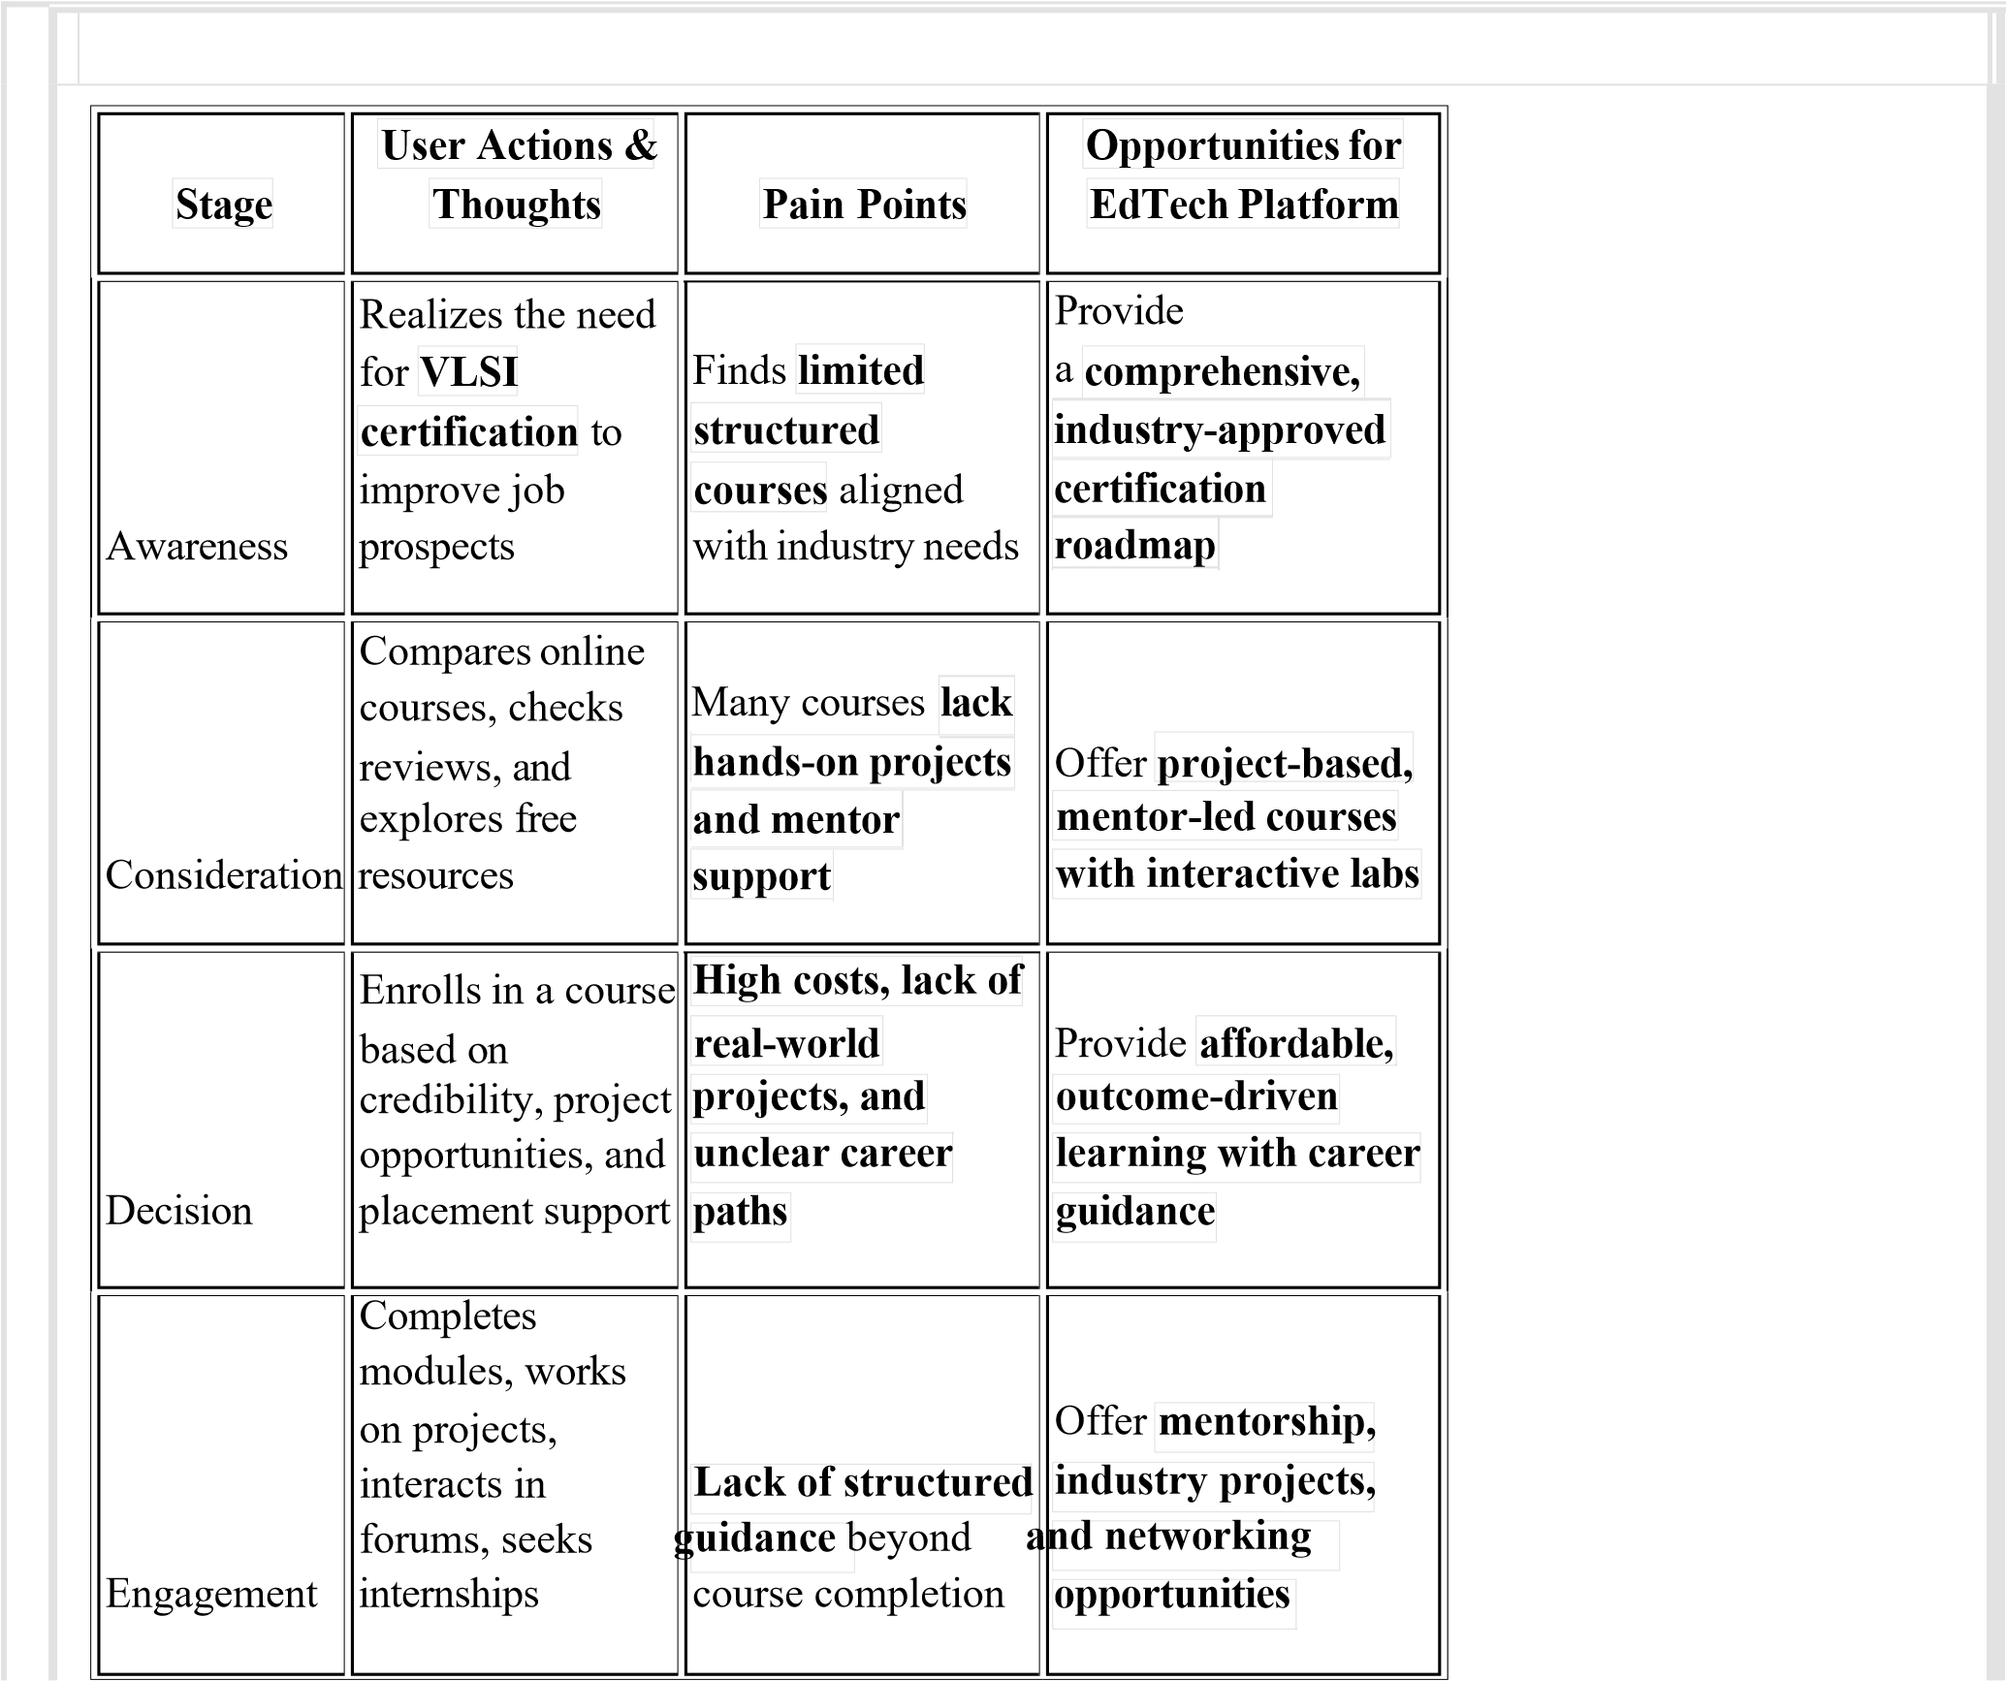

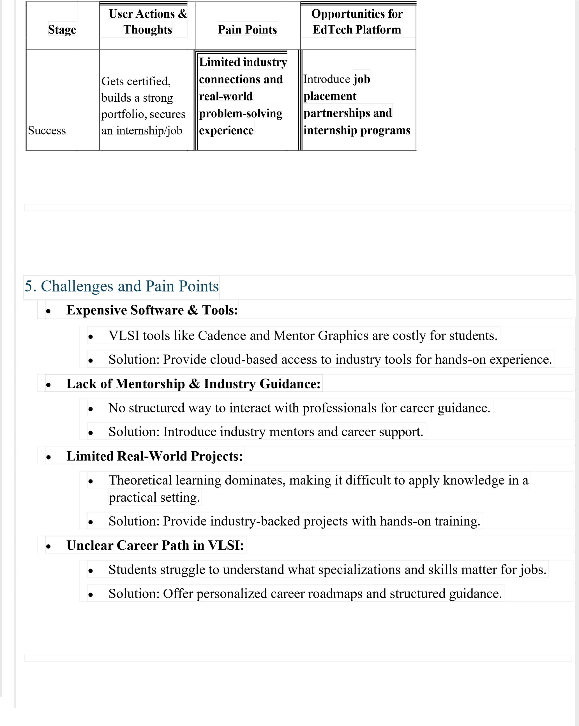



**Conclusion:**

How

the

EdTech

Platform

Can

Help

•

**Provide**

structured,

hands

-

on

certification

courses

**tailored**

**to**

**industry**

**needs.**

•

**Offer**

cloud

-

based

access

to

expensive

VLSI

software

**for**

**real**

**-**

**world**

**experience.**

•

**Connect**

**students**

**with**

mentors,

industry

experts,

and

hiring

partners

**.**

•

**Include**

real

-

world

projects,

internships,

and

placement

assistance

**.**

•

**Keep**

**courses**

affordable

and

accessible

**for**

**students**

**in**

**India**

**and**

**beyond.**



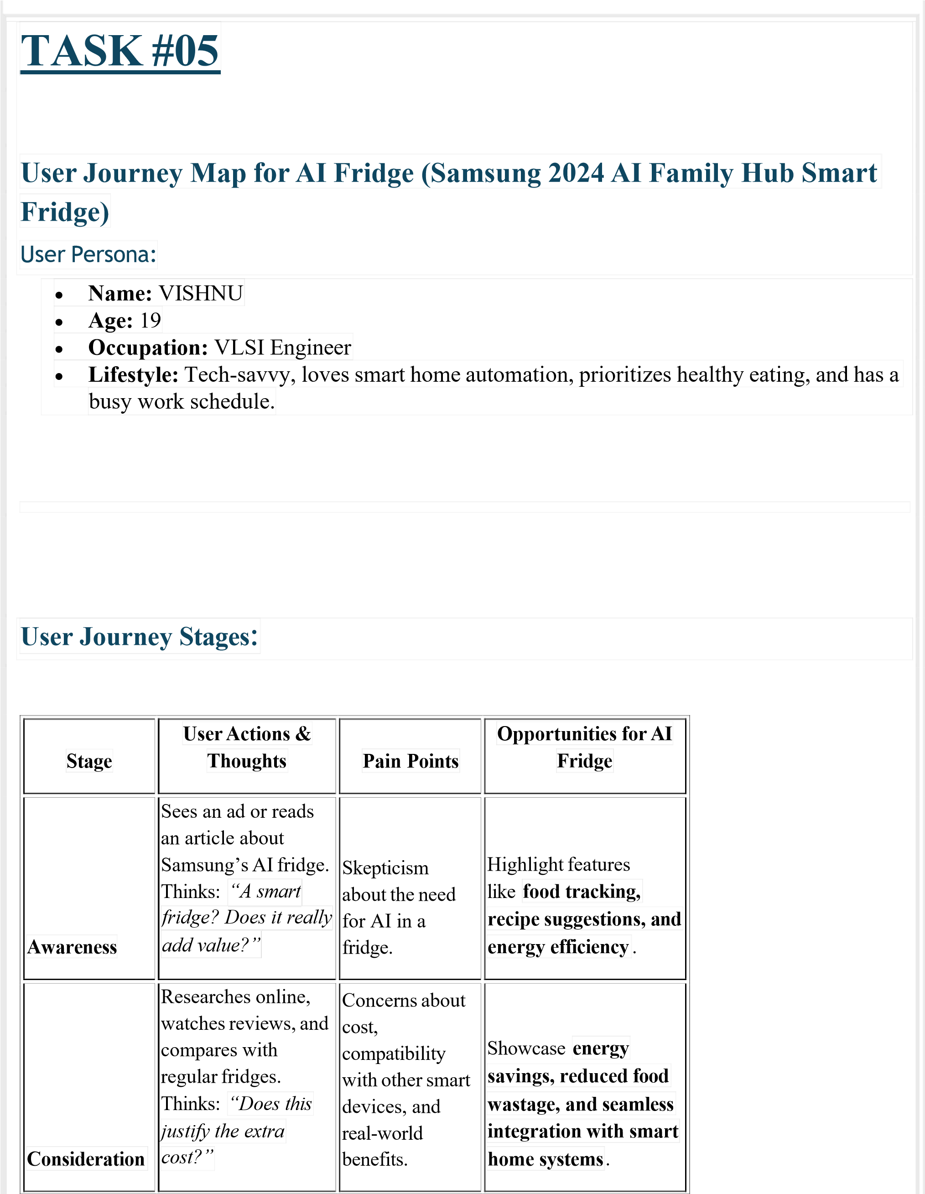

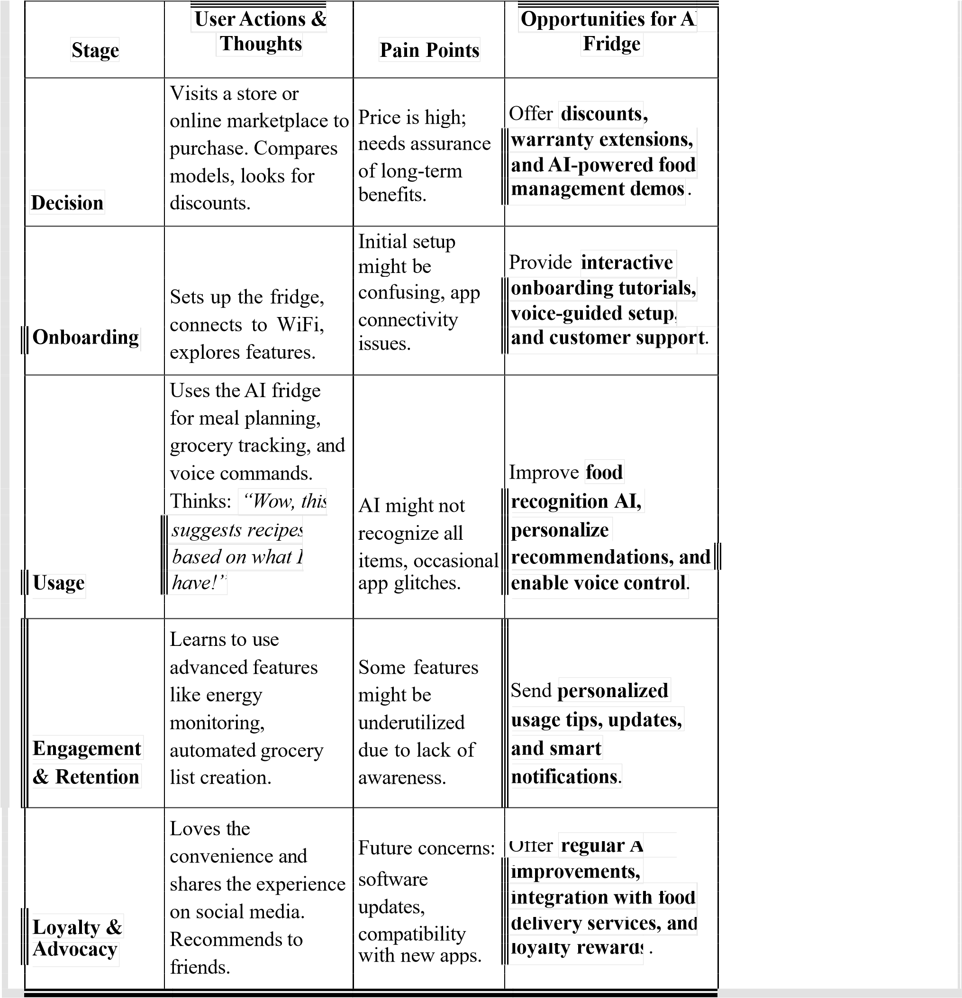

# TASK #06

Storyboarding for Rabbit R1 (AI-Powered Handheld LLM Device)

## *Storyboard Title:* Exploring the Future with Rabbit R1



Storyboard Scenes:

|  |  |  |
| --- | --- | --- |
|  |  | |
| **Scene** | **Rabbit R1 Feature**  **Description User Action/Experience**  **Highlighted** | |
| **1. Awareness &**  **Interest** | Rahul sees a tech  YouTuber review **AI-powered personal**  Excited, he searches for  Rabbit R1, an AI- **assistant, compact &**  more details online.  powered assistant **portable design.** device. | |
| **2. Purchase**  **Decision** | He finds it available for Compares it with other  **Affordable pricing,**  pre-order on an e- AI assistants, then places **ease of access.** | |
| commerce site. an order. |  |
| **3. Unboxing &**  **Setup** | The package arrives, He powers it on, and Rahul unboxes connects to Wi-Fi, and  Rabbit R1. sets up his preferences. | **Simple onboarding, fast AI setup.** |
|  | Rahul asks Rabbit R1  to set reminders, search Amazed by its smooth | **Conversational AI, voice-based operations.** |
| **4. First-Time Use** for information, and voice recognition and control smart home responses. devices. | |
| He uses it for  scheduling,  **5. Daily Use &** Feels more productive  translations, and  **Assistance** and efficient.  answering queries while working. | | **Multi-tasking, quick information retrieval.** |

**Rabbit R1 Feature**

**Scene Description User Action/Experience Highlighted**

Rabbit R1 learns He enjoys how

1. **Customization** Rahul’s daily routine **AI-driven learning and**

personalized and

**& Personalization** and suggests helpful **recommendations.**

adaptive it is.

tips.

Rahul shares his Increased brand

1. **Social Sharing** experience on social **User satisfaction, future**

awareness through word-

**& Advocacy** media, praising the **software updates.**

of-mouth. device.



Final Submission:

* + Create a **Lucidchart storyboard** using the above details.
  + Name the path: *CourseName-CollegeName-BatchNumber-Task06-Storyboarding*.
  + Paste the **Lucidchart link** in a README.md file on GitHub.

# TASK #07

Gap Analysis for Rabbit R1 (AI-Powered Handheld LLM Device)

**Objective:**

To identify gaps between the current Rabbit R1 device capabilities and the desired future improvements for Rabbit R15, a next-generation AI-powered LLM device.



1. Current State (Rabbit R1)

|  |  |  |
| --- | --- | --- |
| **Feature** |  | **Current Capability** |
| AI Model |  | Uses a proprietary LLM for conversational AI |
| Voice Assistant |  | Supports voice-based interactions with limited contextual understanding |
| App Integration |  | Controls select apps using a "Large Action Model" (LAM) but lacks full OS integration |
| Hardware |  | Compact device with a rotating camera, touchscreen, and physical scroll wheel |
| Connectivity |  | Wi-Fi and Bluetooth support, no cellular connectivity |
| Battery Life |  | Moderate, needs improvement for all-day usage |
| Learning & |  | Learns user behavior but lacks deep personalization |

Adaptation



1. Desired Future State (Rabbit R15)

**Feature Desired Improvement**

AI Model Enhanced multimodal AI with better contextual memory and reasoning

|  |  |  |
| --- | --- | --- |
| **Feature** |  | **Desired Improvement** |
| Voice Assistant |  | More natural, human-like conversation with multi-turn memory |
| App Integration |  | Universal app integration with deeper AI control over third-party applications |
| Hardware |  | Improved screen resolution, haptic feedback, and better durability |
| Connectivity |  | 5G-enabled for seamless on-the-go usage |
| Battery Life |  | Optimized power consumption for 24-hour usage |
| Learning & |  | Advanced personalization with real-time AI adaptation |

Adaptation



1. Gap Identification & Solutions

|  |  |  |
| --- | --- | --- |
| **Gap** | **Current Limitation** | **Proposed Solution** |
| AI Contextual Understanding | Lacks long-term memory for conversations | Upgrade LLM to support memory and context retention |
| App Control | Limited to specific apps via  LAM | Develop an AI-driven universal OS layer |
| Connectivity | No cellular connectivity | Add 5G and eSIM support |
| Battery Performance | Drains quickly with AI tasks | Use AI-driven battery optimization |
| Hardware Limitations | Small screen and basic interactions | Introduce larger display and intuitive touch controls |



1. Action Plan for Rabbit R15 Development

|  |  |
| --- | --- |
| **Step Action Item Owner** | **Timeline** |
| 1 Upgrade AI Model AI R&D Team | Q1 2026 |
| 2 Improve Voice Assistant Features NLP Team | Q2 2026 |
| 3 Enhance App Compatibility Software Team | Q3 2026 |

**Step Action Item Owner Timeline**

1. Integrate 5G Connectivity Hardware Team Q4 2026
2. Improve Battery Optimization Power Management Team Q1 2027



Conclusion

By addressing these gaps, Rabbit R15 can evolve into a **powerful AI-driven handheld assistant** with **better connectivity, improved AI intelligence, and extended battery life**, making it a game-changer in personal AI device.

# TASK #08

Extempore Speeches on IT in Different Sectors

## 1) IT in Automobile

"The automobile industry is undergoing a digital transformation, thanks to Information Technology. From AI-driven self-driving cars to smart infotainment systems, IT plays a crucial role in enhancing safety, efficiency, and user experience. Technologies like IoT, cloud computing, and big data analytics help in predictive maintenance, reducing breakdowns and improving vehicle lifespan. GPS navigation, real-time traffic monitoring, and automated emergency response systems have made commuting more convenient and safer. Furthermore, electric vehicles (EVs) leverage IT for battery management, charging infrastructure, and energy optimization. In the near future, connected cars and autonomous driving will revolutionize transportation, making roads smarter and more efficient."



## 2) IT in Metro Rail

"Metro rail systems worldwide rely heavily on IT for smooth operations, passenger convenience, and safety. Automatic train control (ATC) and signaling systems ensure timely and safe travel. IT-driven ticketing solutions, such as RFID smart cards and mobile payment apps, enhance user experience while reducing manual work. AI-based predictive maintenance helps monitor train and track conditions, preventing service disruptions. Real-time passenger information systems display train schedules, delays, and safety alerts, improving public transport efficiency. Moreover, IT supports security with AI-powered surveillance and facial recognition. The future of metro rail lies in AI-powered automation, reducing human intervention while making urban mobility more seamless and intelligent."



## 3) IT in Avionics

*"*Avionics—the technology behind aircraft electronics—heavily depends on IT to ensure safe and efficient air travel. Modern aircraft are equipped with advanced flight management systems (FMS), autopilot functionalities, and real-time weather tracking, all powered by sophisticated software. IT enables air traffic control (ATC) systems to efficiently manage flight routes, minimizing delays and improving airspace utilization. Cybersecurity in avionics is also crucial to protect against hacking threats in increasingly connected aircraft. Furthermore, in-flight entertainment, Wi-Fi services, and real-time aircraft diagnostics use IT to enhance passenger experience and flight safety. As aviation technology advances, artificial intelligence and big data analytics will optimize fuel efficiency, reduce maintenance costs, and pave the way for fully autonomous aircraft”.

# TASK #09

Stakeholder Mapping

Stakeholder mapping helps identify key individuals or groups involved in a project, product, or business, categorizing them based on their influence and interest. Below is a general stakeholder mapping framework, which can be customized based on your specific project or business.



## 1. Categories of Stakeholders

Stakeholders can be classified into four main quadrants based on their **Interest** and **Influence**:

|  |  |
| --- | --- |
| **High Influence / High Interest** | **High Influence / Low Interest** |
| Key decision-makers, investors, executives, government regulators, customers, and major partners. | Government authorities, media, legal advisors, industry bodies, and regulatory compliance officers. |
| **Low Influence / High Interest** | **Low Influence / Low Interest** |
| Employees, end-users, vendors, community members, and advocacy groups. | General public, minor suppliers, and indirect competitors. |



## 2. Stakeholder Map for a Product or Startup (Example: Rabbit R1 AI Assistant)

**Stakeholder**

|  |  |
| --- | --- |
| **Examples Category** | **Engagement Strategy** |
| Tech enthusiasts, early  **Customers (Users)** adopters, general consumers. | Collect feedback, offer user-friendly support, and run marketing campaigns. |
| **Investors & Board** Venture capitalists, angel  **Members** investors. | Regular progress updates, financial reports, and vision alignment. |
| **Regulators &** Data protection agencies **Compliance Bodies** (GDPR, CCPA). | Ensure legal compliance, maintain transparency, and follow ethical AI guidelines. |
| Cloud providers, chipset  **Technology Partners** manufacturers. | Establish strong technical collaborations and optimize product performance. |
| **Employees &** Engineers, designers,  **Developers** marketers, and sales teams. | Provide training, career growth opportunities, and a strong workplace culture. |
| Other AI assistants (Alexa,  **Competitors**  Google Assistant, Apple Siri). | Market analysis, competitive differentiation, and innovation. |
| **Media &** Tech bloggers, journalists, **Influencers** YouTubers. | PR campaigns, product reviews, and partnerships for brand awareness. |



## 3. Visual Representation of Stakeholder Map

A **Power-Interest Grid** can be used to represent stakeholder mapping visually:

* **High Power, High Interest** → **Manage Closely** (Investors, Customers, Government)
* **High Power, Low Interest** → **Keep Satisfied** (Regulators, Media, Compliance Bodies)
* **Low Power, High Interest** → **Keep Informed** (Users, Employees, Developers)
* **Low Power, Low Interest** → **Monitor with Minimal Effort** (General Public, Minor Suppliers)

# TASK #10

In addressing the challenge of enhancing the contextual understanding capabilities of the Rabbit

R15 Large Language Model (LLM), a pertinent reference is the study titled "Testing AI

Performance on Less Frequent Aspects of Language Reveals Insensitivity to Underlying Meaning" by Dentella et al. (2023). Cite turn0academia21

**Inference Report:**

This study critically examines the limitations of LLMs, specifically GPT-3, in processing less common linguistic constructions. The researchers assessed GPT-3's performance on tasks involving grammatical illusions, semantic anomalies, and complex nested hierarchies— structures that are infrequent and likely underrepresented in training data. The findings revealed that GPT-3 struggled with these constructions, often providing responses that lacked a true understanding of the underlying meaning, even when high-frequency words were used.

**Implications for Rabbit R15 Development:**

The insights from this study suggest that to enhance the Rabbit R15's contextual understanding, especially concerning rare or complex linguistic patterns, it is essential to:

1. **Diversify Training Data:** Incorporate a broader range of linguistic structures, including less frequent and complex constructions, into the training datasets to improve the model's exposure and adaptability.
2. **Enhance Semantic Processing:** Develop mechanisms that enable the model to grasp the underlying meanings of sentences beyond surface-level word associations, potentially through advanced semantic parsing techniques.
3. **Implement Robust Evaluation Metrics:** Adopt comprehensive testing frameworks that assess the model's performance on both common and uncommon linguistic constructs to ensure a more holistic understanding.

By addressing these areas, the Rabbit R15 can achieve a more nuanced and accurate contextual understanding, thereby improving its overall performance in real-world applications.

**Source:**

**arxiv.org Testing AI performance on less frequent aspects of language reveals insensitivity to underlying meaning February 24, 2023**

# TASK #11

Empathy Process Flow for Rabbit R15

## 1) Identify and Fix Any Product Issue

**Identified Issue:** Limited Contextual Understanding in Conversational Scenarios

• The Rabbit R15 struggles with understanding and responding accurately to complex queries involving nuanced contexts or rare linguistic structures.

## 2) Explore New Features to Address the Issue

* **Enhanced Context Retention:** Improved memory to retain context over longer interactions.
* **Adaptive Learning Model:** Self-improving responses based on user interactions.
* **Multi-Modal Integration:** Ability to process and interpret voice, text, and visual inputs simultaneously.
* **Personalized AI Experience:** Customizable responses based on user preferences and usage patterns.

## 3) Prepare an Empathy Flow Using an Empathy Template

**Step Description**

Define target users: Tech enthusiasts, professionals using AI for

1. **User Persona** productivity, and accessibility users.

**Step Description**

* + Accurate and contextually aware AI responses. - Enhanced

1. **User Goals &** personalization for different user requirements. - Faster and seamless AI

**Needs** interaction.

* + AI misinterprets complex queries. - Loss of context in extended

1. **User Pain Points**

conversations. - Lack of customization for different user needs.

**Think:** "Why doesn’t AI understand my unique phrasing?" **Feel:**

1. **Empathy Mapping**

Frustrated when responses lack accuracy. **See:** Other AI models with

**(Think-Feel-See-Say-** better conversational capabilities. **Say:** "This AI needs to be more

**Do)**

intuitive." **Do:** Look for alternatives or try workarounds.

* + **Context Aware NLP Algorithms**: Improving AI’s ability to

1. **Solutions &** understand nuanced queries. - **User Memory Retention**: Storing past

**Feature** interactions for better personalization. - **Adaptive Voice & Visual Enhancements**

**Learning**: Integrating multi-modal features for improved accessibility.

* + Conduct usability testing with diverse user groups. - Gather feedback

1. **User Validation &** for iterative AI model improvements. - Deploy phased updates based on

**Testing** testing insights.

This **Empathy Process Flow** ensures that Rabbit R15 aligns with user expectations while resolving its limitations through intuitive AI advancements.

# TASK #12

Example Product: SkillBridge - A Personalized Learning Platform

## 1) User Research

**Objective:** Conduct research to identify the needs of students and professionals seeking skill- based certifications.

* **Target Audience:** College students, working professionals, career changers.
* **Research Methods:** 
  + Online surveys with students and professionals. o Interviews with educators and hiring managers. o Competitor analysis of leading Ed-Tech platforms (Coursera, Udemy, LinkedIn Learning).
  + Analysis of industry trends and in-demand certifications.
* **Key Findings:** 
  + 70% of learners prefer interactive, hands-on learning experiences.
  + 60% struggle with tracking progress and motivation. o 80% find traditional certification courses expensive.



2) Persona Creation

## Persona Name: K.vishnuvardhanachari

**Role:** Engineering Student (Second Year)

**Age:** 19

**Location:** Bangalore, India

1. Demographic Information:

* + **Education:** Pursuing B.Tech in Electronics and Communication Engineering
  + **Income Level:** Limited (Dependent on parents, looking for affordable courses)
  + **Tech-Savvy Level:** Moderate (Uses mobile apps for learning)
  + **Preferred Language:** English

1. Goals & Objectives:

* + Gain industry-relevant certifications in **VLSI & Embedded Systems**.
  + Improve practical knowledge through hands-on projects.
  + Secure an internship at **ISRO or DRDO**.
  + Learn efficiently within limited time due to academic workload.

1. Psychographic Information:

* + Highly motivated but overwhelmed by multiple learning platforms.
  + Prefers **structured learning paths** with real-world applications.
  + Seeks expert mentorship and networking opportunities.
  + Likes gamified learning with quizzes and rewards.

1. Behavior & User Preferences:

* + Spends 2-3 hours per day on online courses.
  + Uses mobile learning apps like Coursera, Udemy, and YouTube tutorials.
  + Prefers **short, engaging video lectures** over long text-based content.
  + Likes **interactive assignments and live Q&A sessions**.
  + Engages with discussion forums for peer learning.

1. User Journey:

**Step 1:** Learns about SkillBridge through a college seminar.

**Step 2:** Signs up and selects a **VLSI Certification Pathway**.

**Step 3:** Starts self-paced learning with video lectures and exercises.

**Step 4:** Participates in **live industry expert sessions**.

**Step 5:** Completes a **capstone project and earns certification**.

**Step 6:** Uses the certificate to apply for VLSI internships.

1. Challenges & Pain Points*:*

* + **Lack of Affordable Courses:** Many premium platforms are expensive.
  + **Overwhelming Course Choices:** Difficulty in selecting the right learning path.
  + **Time Constraints:** Balancing academic studies with skill-building.
  + **Limited Hands-on Experience:** Needs industry projects for better learning.
  + **Difficulty in Networking:** Wants industry connections for job opportunities.



Final Thoughts:

By addressing these user needs, SkillBridge can differentiate itself through:

* + Affordable, **structured certification courses**.
  + AI-powered **personalized learning recommendations**.
  + **Industry collaborations** for internship placements.
  + Gamification for **higher engagement and motivation.**